**TITLE (Helvetica 14, bold)**

Name Surname1, Name Surname2 (Helvetica 12)

1 Affiliation 1; 2 Affiliation 2;… (Helvetica 11)

E-mail: presenting.author@univ.edu (Helvetica 10)

(Below, text sample for your one-page abstract body: The use of a TOC graphic is highly recommended (see below). The abstract should be saved and submitted with filename: Surname_Name.docx (of the presenting author). Respect the format,..., and have fun!!).

(Helvetica 11) In a universe where test tubes dance and beakers sing, behold the grandeur of Seville, a city where atoms tap dance on cobblestone streets and biomolecules perform intricate ballets under the moonlit sky. Picture this: a symphony of biologically relevant chemical reactions orchestrated by the flamenco rhythms of the local populace [1]. In Seville, the scent of freshly brewed cell culture media mingles with the aroma of orange blossoms, creating an olfactory masterpiece that even the most discerning alchemist would envy. Here, amidst the hustle and bustle, scientists gather to discuss the wonders of chemical biology, their voices mingling melodiously like the ingredients of a good gazpacho, each eager to share their latest creations and discoveries.

Besides a backdrop for scientific discourse, Seville is a living, breathing laboratory of culture and history. From the Giralda to the enchanting alleys of the Santa Cruz neighborhood, every corner of this city tells a story—a story of passion, innovation, and the eternal quest for knowledge. So come, fellow seekers of truth, and let us embark on a journey of discovery amidst the enchanting streets of Seville, where even the most complex biochemical reactions will be rendered simpler by the magic of this wondrous city [2].

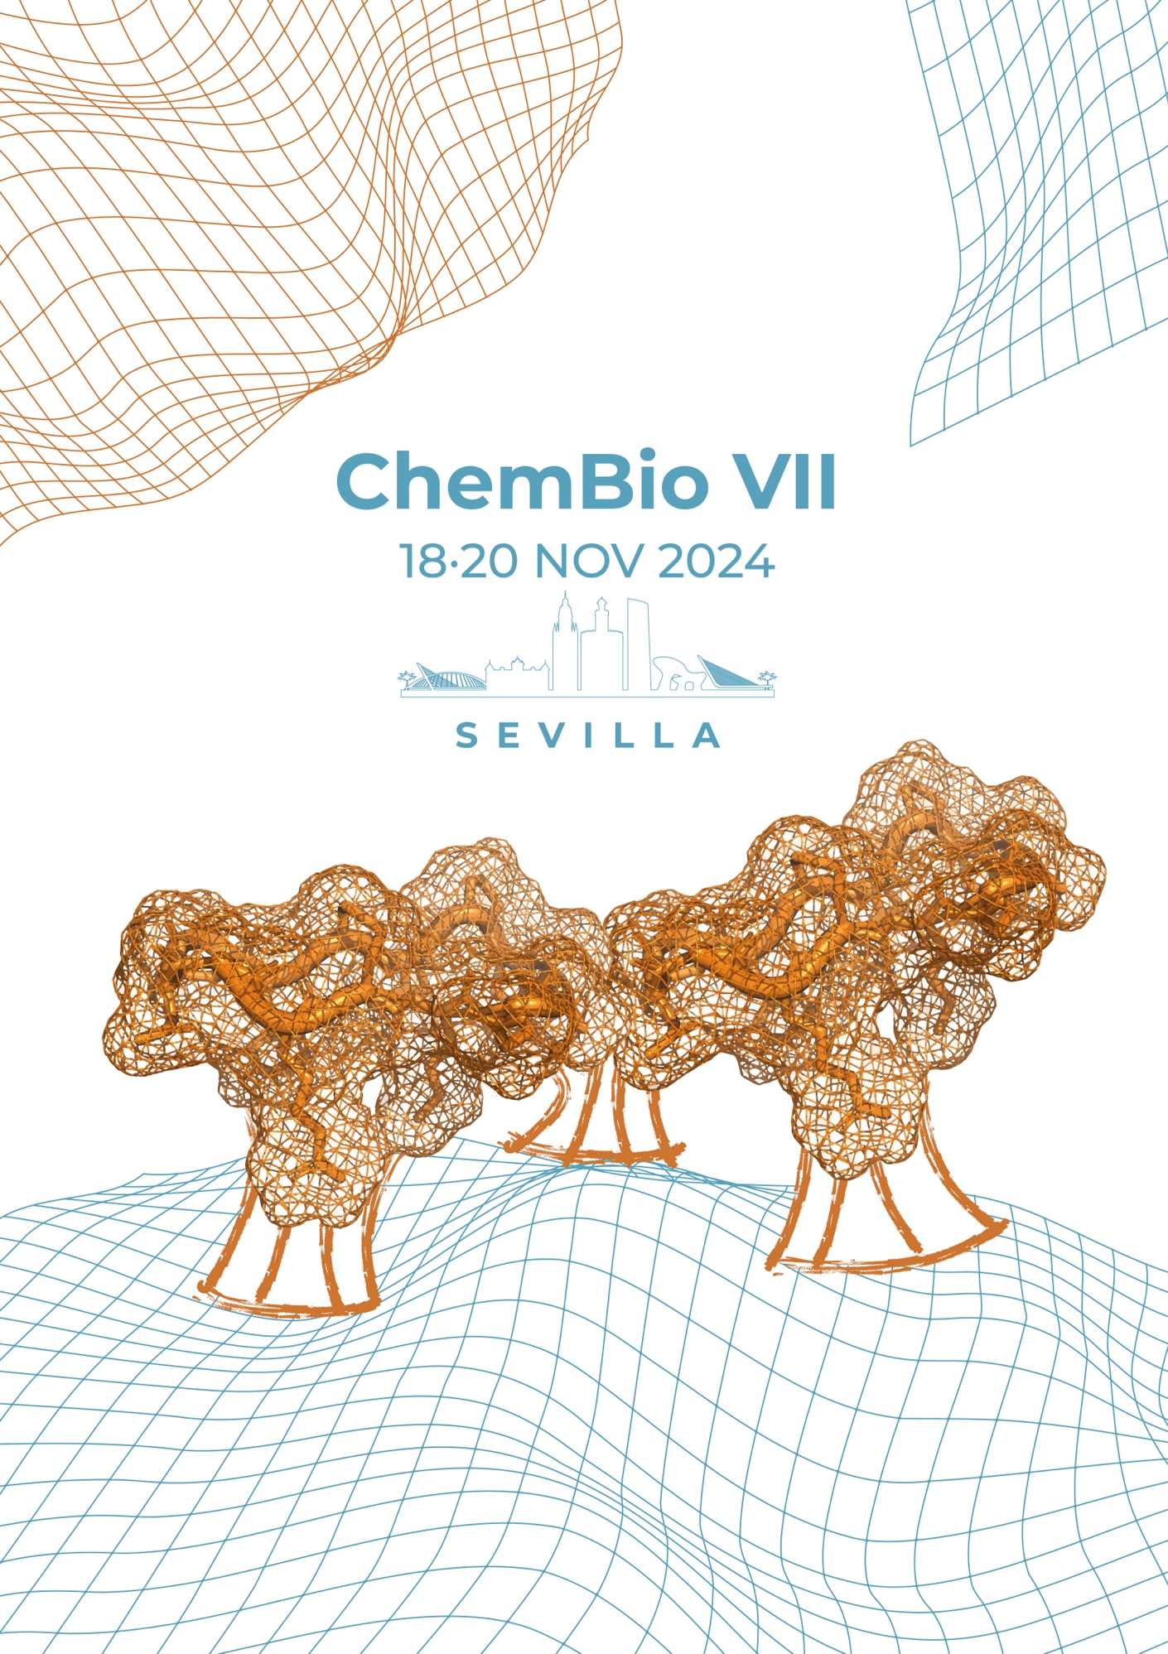

**Figure 1.** Trimerization of cyclic peptides at the surface of “Las Setas” square in Seville.

**REFERENCES**

1.  C. Biologist, C. Gpt. *Proceedings of Sevillian Academy of Funny Chemists* **2024**, ***11***, 1492-1992

2. C. Gpt, B. Chemist. *Sev.Chem.Int.Ed.*. **2024**, *11*, 1118-1120

**ACKNOWLEDGEMENTS**

The authors acknowledge the Funding Agency FA (Grants XX-2017-YYY-1 and PIDXXXX-11YYYRB-I00) for financial support.